29) Aim: To Design Deterministic Finite Automata using simulator to accept the input string “bc” ,”c”,and ”bcaaa”.

Diagram:

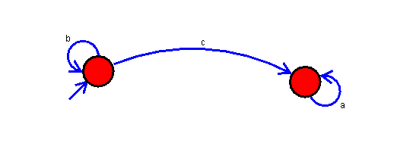

Result:

Successfully Executed Deterministic Finite Automata using simulator to accept the input string “bc” ,”c”,and ”bcaaa”.